Functional Specification – Bank Confirmation Report

Export-Import Bank of Thailand

|  |  |
| --- | --- |
| Project Code: | <EXPJ.B.PJ.TH.EXIMTH*CBS_IMP.CC> |
| Reference: | <Client BZ Reference and Description> |
| Release: | 2.1 |
| Status: | Released for External Distribution |
| Date | 8-Aug-23 |

Contents

Introduction 4

Functional Summary 6

Functional Specification 6

1. 1. ENT-FS08 – Bank Confirmation Report 6

1.1. Purpose 6

1.2. Background / Functional Requirements 6

1.3. Supported Sample Transaction and Case from Customer 6

1.4. Menu Modification 10

1.5. Screen Layout and Data Sheet 10

1.6. Business Rule / Logic 10

1.7. To-be Processing 12

1.8. File /API Layout and Data Sheet 14

1.9. Report Layout and Data Sheet 14

1.10. Additional Impacts 25

Document Acceptance & Release Notice

This is a managed document. Changes will only be issued as a complete replacement document covered by a release notice. All replaced documents shall be destroyed immediately and copies of any obsolete forms destroyed. This document has not been released for use until authorized by the Manager/Project Manager.

This is release 2.1 of the document.

|  |  |  |  |
| --- | --- | --- | --- |
| Reviewed & Approved |  | Date |  |
|  | | | |
| Accepted |  | Date |  |
|  | |  |  |
| Authorized |  | Date |  |
|  | | | |

Build Status

|  |  |  |  |  |
| --- | --- | --- | --- | --- |
| Release | Date of Release | Prepared by | Reviewed by | Comments |
| 1.0 | 10-July-2023 | Emy Bartolome | Marites Magsajo |  |
| 1.1 | 20-July-2023 | Emy Bartolome | EXIM Operations Team |  |
| 1.2 | 27-July-2023 | Emy Bartolome | EXIM Operations Team | Updated report generation flow  Harmonized other sections on parameter criteria |
| 2.0 | 27-July-2023 | Emy Bartolome | EXIM Operations Team  Leoneil Batulan |  |
| 2.1 | 08-Aug-2023 | Emy Bartolome | K. Wallapa Loardkhem | Adjustments on illustration+minor revisions on data sheet |

# 

# Introduction

CBS Foundation and Enterprise workshop activity was conducted at the Export-Import Bank (EXIM) of Thailand premises which highlighted CBS core features in terms of general usability, reference data set up, cross product services, including Customer, Collateral, Limits and Common Utilities. It also covered main integration points for EXIM CRM/LOS into CBS Customer and Limits modules respectively. Gaps were also identified during this stage, hence Functional Specifications documentation to rectify the gaps are prepared for review and approval by EXIM business users and stakeholders.

Abbreviations

The following list defines the abbreviations used in this document.

|  |  |
| --- | --- |
| EXIM | Export Import Bank of Thailand |
| TOR | Terms of Reference |
| AS/400 | EXIM Core Legacy System |
| LOS | EXIM Loans Origination System |
| CRM | EXIM Customer Relations Module |
| SSI | Silverlake Symmetri |
| CBS | Silverlake Symmetri Core Banking System |
| CSD | CBS Common Static Data Module |
| ENT | CBS Enterprise Modules |
| MCL | CBS Customer Module |
| LMT | CBS Limits Module |
| BPM | CBS Business Process Management |
| LND | CBS Lending Module |
| DEP | CBS Deposits Module |
| GFT | CBS Global Funds Transfer Module |
| CUT | CBS Common Utilities *Includes Document Management |
| Core- RLoan | EXIM Core Legacy System for Restructuring Loan |
| Core - Insurance | EXIM System for Insurance |
| L/G Claim | EXIM System for Letter of Guarantee Claim |
| BU | EXIM Business Unit Team |

References

|  |  |  |  |
| --- | --- | --- | --- |
| ID | Title/Summary | TOR Status | Module |
| G-64 | Able to display outstanding debt details such as principal, interest, interest rate, maturity date according to the form specified by the bank and can be printed.  สามารถแสดงรายละเอียดหนี้คงค้าง เช่น เงินต้น ดอกเบี้ย อัตราดอกเบี้ย วันครบกำหนด ตามแบบฟอร์มที่ธนาคารกำหนดและสั่งพิมพ์ได้ | Customization | ENT |
| G-69 | Bank Confirmation: The information received can be taken through a connection to other systems that the bank has specified. and display information by day month year that you want by showing all types of deposit accounts, outstanding debts/accrued liabilities for every transaction and can override the data before printing/exporting the data  Bank Confirmation: สามารถนำข้อมูลที่ได้รับผ่านการเชื่อมต่อกับระบบอื่นที่ธนาคารกำหนด และแสดงข้อมูล ตามวันเดือนปี ที่ต้องการได้ โดยแสดงยอดบัญชีเงินฝากทุกประเภท, หนี้คงค้าง/ภาระคงค้างทุกธุรกรรม และสามารถ Override ข้อมูลได้ บนแบบฟอร์มที่ธนาคารกำหนด และสามารถสั่งพิมพ์ได้ | Customization | ENT |
| G-77 | Able to generate reports on all outstanding balances of customers. For the auditor / OPG, which can be separated into principal and interest According to the past period that can be set, such as the end of the day, month, etc., can be printed. according to the form specified by the bank  สามารถสร้างรายงานภาระยอดคงค้างทั้งหมดของลูกค้า เพื่อผู้ตรวจสอบบัญชี/สตง. โดยสามารถแยกเป็นเงินต้น และดอกเบี้ยได้ ตามช่วงเวลาย้อนหลังที่กำหนดได้ เช่น สิ้นสุดวันที่, เดือน เป็นต้น ตามรูปแบบที่ธนาคารกำหนดและสั่งพิมพ์ได้ | Customization | ENT |

# Functional Summary

This section provides a functionality list of the software product or any modifications on existing Symmetri CBS product.

|  |  |  |
| --- | --- | --- |
| ID | Title/Summary | References |
| FS_EXIMTH_ENT_FS08 | Bank Confirmation Report | TOR |

# Functional Specification

## 1. ENT-FS08 – Bank Confirmation Report

### Purpose

The purpose of this document is to provide the solution through functional specification resulting from the TOR and Gaps identified during the Product Workshop activity held April 26 to May 16, 2023 at EXIM Bank of Thailand.

วัตถุประสงค์ของเอกสารนี้คือการกำหนดข้อกำหนดการทำงานที่ได้รับมาจาก TOR และ Gap ที่พบระหว่างกิจกรรม Product Workshop ที่จัดขึ้นในวันที่ 26 เมษายนถึง 16 พฤษภาคม พ.ศ. 2566 ณ ธนาคารEXIMแห่งประเทศไทย

### Background / Functional Requirements

Functional Requirement: System should be able to generate inquiry or report form:

* Outstanding Debt Details (Principal, Interest, Maturity Date, etc)
* Generate Bank Confirmation Report
* Generate Outstanding Balances Reports

Also need searching criteria for enquiry the particular bank confirmation report to pick up and send to customer later.

### Supported Sample Transaction and Case from Customer

ธุรกรรมและกรณีตัวอย่างที่รองรับจากลูกค้า

#### Bank Confirmation Sample Report

##### Bank Confirmation for Audit Purposes

* Need to be provided as daily report

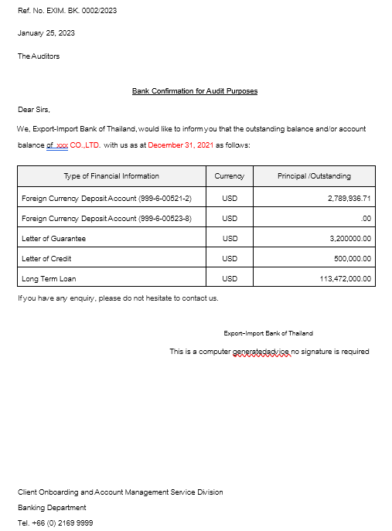

##### State Auditor Office Letter – Thai version

Need to be provided as monthly report

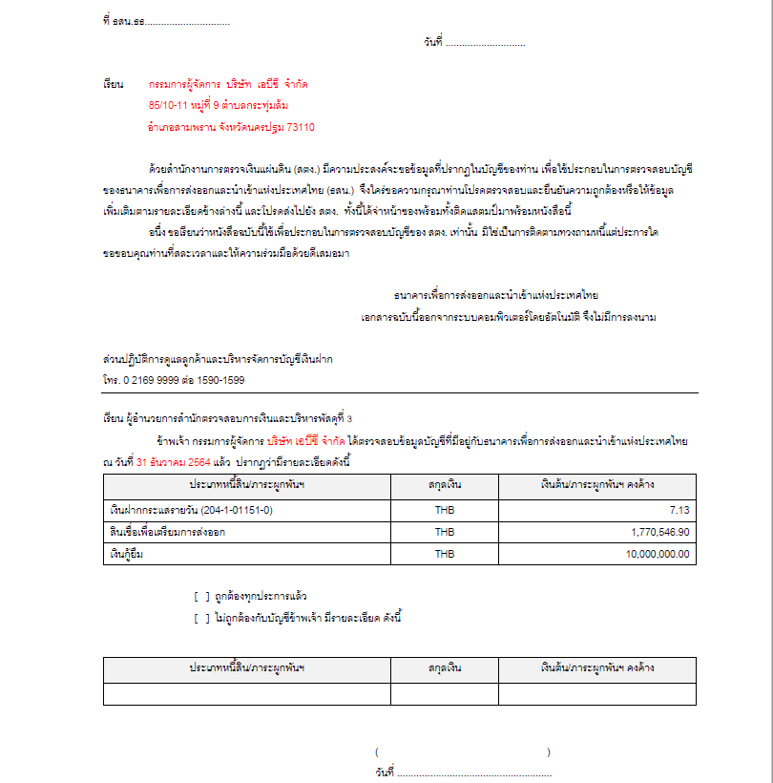

##### State Auditor Office Letter – English version

- Need to be provided as monthly report

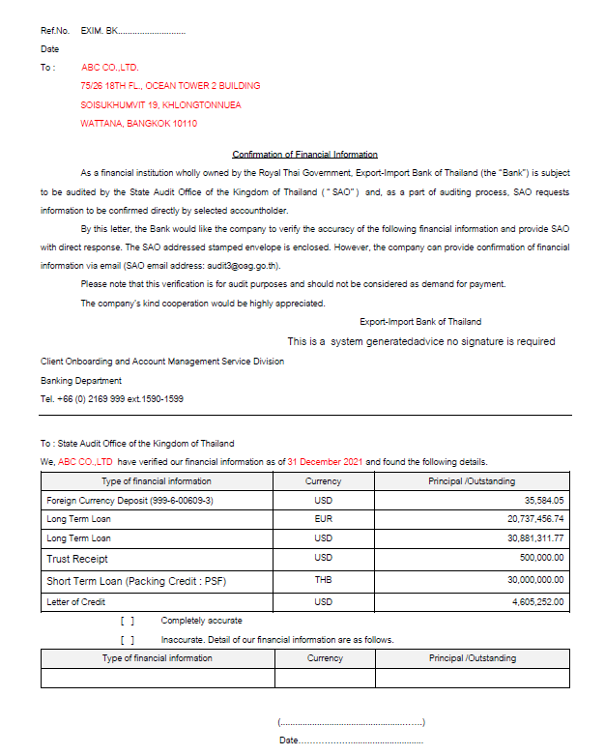

##### Outstanding Balance Report

* Need to be provided as daily report

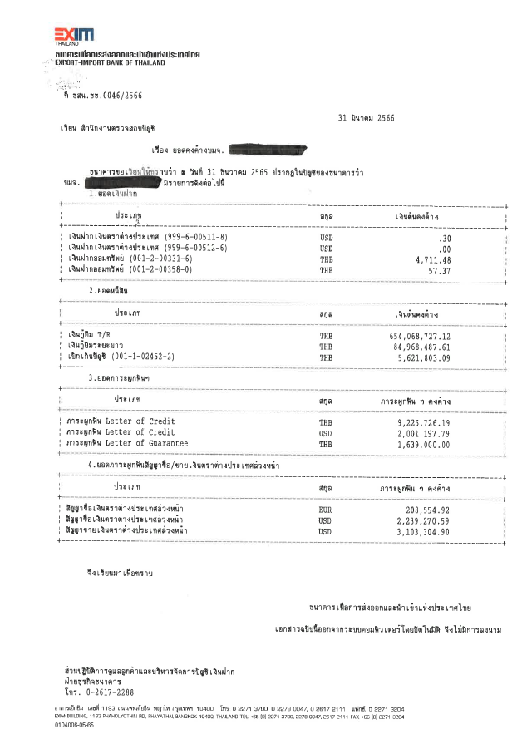

##### Loan Details

* Need to be provided as monthly report

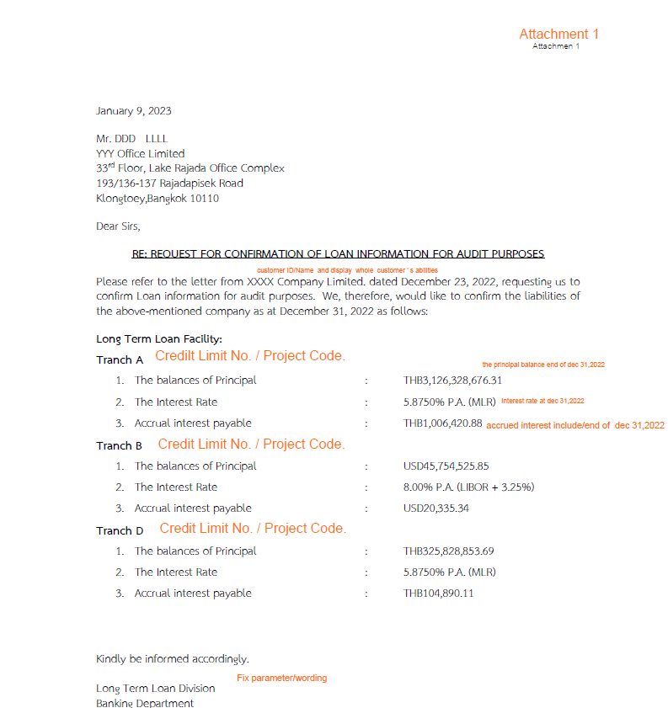

### Menu Modification

Not applicable.

การปรับเปลี่ยนเมนู

### Screen Layout and Data Sheet

เค้าโครงหน้าจอและ data sheet

Screen Data Sheet

Not applicable.

### Business Rule / Logic

This section describes the data flow, availability and high level solution approach as to how the required reports will be generated from CBS.

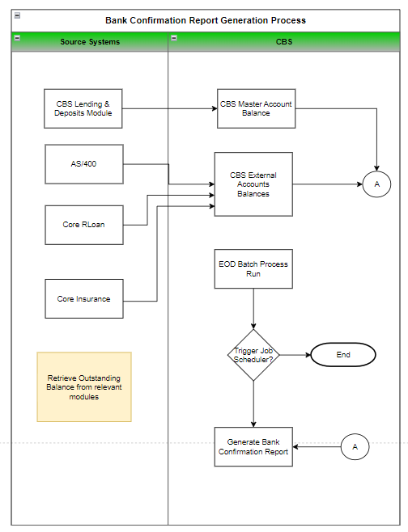

Storage and archiving rules to be determined by EXIM

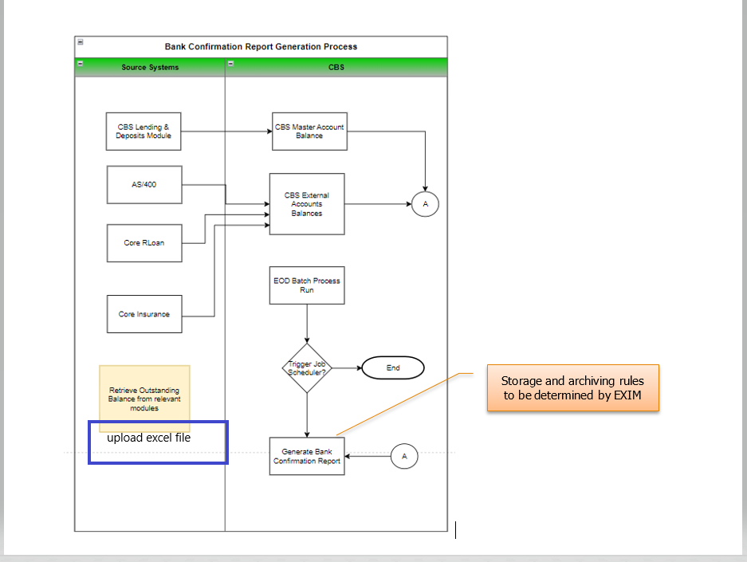

#### Business Transaction Modules

All transaction-based system of EXIM will be providing account balances to CBS9 which will be used as basis of generating report:

* CBS – Deposits (Deposit Accounts for Current, Savings, Fixed Deposit)
* CBS – Lending (Short Term, Long Term Loans, etc.)
* AS/400 – Trade Finance (Letters of Credit, Export/Import Bills purchased, Guarantees, Export Bills Collection, Trust Receipt, Pre Shipment Financing, Forward Contract (Purchase/sale) )
* Core R-Loan ( Restructuring Loan)
* Core – Insurance ( All contingent/liabilities under export insurance)
* L/G Claim (any liabilities under Letter of Guarantees which its source data from excel file)

#### CBS Master Account Repository

A centralized master account will be available in CBS which will maintain updated balances from business transaction modules where transaction modules or systems will be providing data based on interface/upload method applicable for the source system:

* Internal Master Account – Used by transacting modules in CBS (Deposits, Lending) where balances are synched online real time
* External Master Account – Used by external systems in AS/400 – Trade Finance, Core R-Loan, Core – Insurance, L/G Claim where balances will be interfaced/upload based on applicable method of the source system

#### Data Source

* In order for the reports to be able to reflect the required upto-date outstanding balances, a common repository will be designated to be used:
  + Current system's main repository of upto-date balances for Deposits, Lending account’s transaction processing events are updating CBS Product Master account repository. This data source currently contains various balances in terms of Principal, Interest, Outstanding, which is based on Balance type and amount a particular business domain is able to maintain.
  + Similarly, when EXIM other external system’s balances will be interfaced, required information will be replicated to external master account tables which will be confirmed during technical design stage. Required 3rd party systems should populate required data to this repository so it can be included in outstanding report.
  + Option to perform Incoming File Upload for external system’s balances in order to support LG Claim oustanding and reflect it as part of Bank confirmation reports:
    - New file format with structure aligned with external system balances repository (header and detail) to be made available.
    - Incoming File upload to be performed by BU manually where data file contains information about external system balances
    - As the option to perform file upload is only during INP – Input Phase of the system, balances for L/G will be reflected only on the next EOD batch process run.

#### Job Scheduler

Job scheduler is the system capability to raise event when a particular event condition or period is reached. This is performed on an ideal time when low system-utilization is anticipated (after EOD batch process run and prior official banking hours, timing between 2:00am to 5:00am daily). The event scheduler will be activated on a user-defined periodic basis using the balances as per last EOD batch run (T-1).

### To-be Processing

* End of Month report and daily report to be generated by branchwise from CBS9 in order to comply with G-69 requirement
* This EOM report and daily report will include data from CBS9 and external product for:
  + Lending
  + Deposits business domain
  + 3rd Party systems, AS/400
  + Core RLoan
  + Core Insurance
  + L/G Claim
* Support for all template defined as clause 1.3. Supported Sample Transaction and Case from Customer
* Loan Details Attachment need to be supportted as clause 1.3. Supported Sample Transaction and Case from Customer

#### Automated Background Process

* EOM (End-of-Month) and EOD (End-of-Day) background process to be introduced to automatically generate Bank Confirmation Report given different report templates provided by EXIM.

#### Report Request Log

• System to spool the generated report once the scheduled job event date is reached. The report file will contain balances of all customers, per page size A4 .

• CBS Report Request Log is in a summary table format where standard search/filter functions are made available:

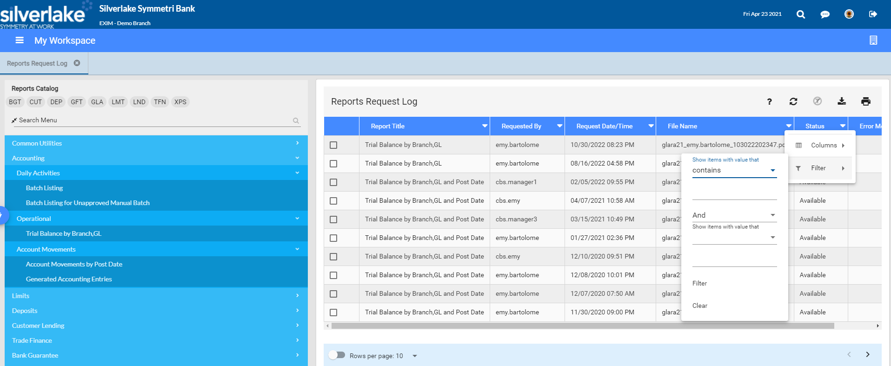

Filter options

In order to retrieve report of a given customer on a specific date, please refer to steps itemized in Report Generation (section 1.7.3) and Accessibility of Report (section 1.7.4)

#### Report Generation

* On a daily basis, Daily report for Bank Confirmation will be generated
  + Bank Confirmation for Audit Purposes
  + Outstanding Balance Report
* If system run date falls on applicable end of month date, EOM identified reports will be generated:
  + State Auditor Office Letter – Thai version,
  + State Auditor Office Letter – English version
  + Loan Details report.
* This will be made possible thru a new Job scheduler event that will created in order to perform the task of generating the report, as part of system ’s background process
* Bank Confirmation reports will contain data from business transactions performed within CBS. However, this solution should also include external products integrated from other third party systems such as:
  + AS/400Trade (for Trade-related transactions and Forward contract)
  + Core- RLoan (Restructuring Loan)
  + Core Insurance (Contingent information)
  + L/GClaim
* There will be a provision to display outstanding debt details such as principal, interest and other available amount information (that source module is able to provide), will be considered as outstanding balance of a given account will be made available
* Facility to override the data before printing/exporting the data will be supported by copying the contents of CBS9-generated report and paste it to Word document that BU can prepare separately.
* In the event that a customer requests for outstanding balance report of previous month, day, or year, BU will perform the following:

1. Retrieve the relevant file either from CBS Report Request Log or archived repository of generated files
2. Open the report file using designated application (e.g. Arcrobat reader for PDF, etc.) and perform search of customer name to retrieve the page where customer’s outstanding details are available. Printing of a specific or required page that contains requested customer information’s balances can also be achieved.

#### Accessibility of the Report

* Single PDF file will be generated for each report (daily or monthly) where all customer records reflecting accounts’ outstanding balances on a given report generation date will be made available.
* Each report will be generated with a given structure in order for BU team to easily retrieve files either from CBS Reports Request Log or other designated repository of EXIM IT Team.

Currently in CBS, File Name of the report has structured file name as: Program ID + User Code + Date/Time + 2 digit sequence number

|  |  |
| --- | --- |
|  | Program ID: glara911  User ID:cbs.user1  Date: July 26, 2023  Time:10:05pm |

#### Archiving

As EXIM requires for generated reports to be accessible from the system for at least 2 years, management, archiving of the generated report will be based on discretion of EXIM IT Infrastructure Team considering the implication or possible impact on system’s performance.

### File /API Layout and Data Sheet

Not applicable.

### Report Layout and Data Sheet

#### Bank Confirmation for Audit Purposes

##### Report Parameter Criteria

| Report Parameter Field | Source/Validations |
| --- | --- |
| Paper Size | A4 (one page per customer) |
| Search Criteria | All customer records from CBS9 Product Master Account repository (Internal and External account tables) |
| This option will be limited to particular date from last EOD batch process run  Option to specify current, future date or back dated **beyond** last EOD batch process run will be restricted. |
| Generation Frequency | Daily |

##### Report Layout

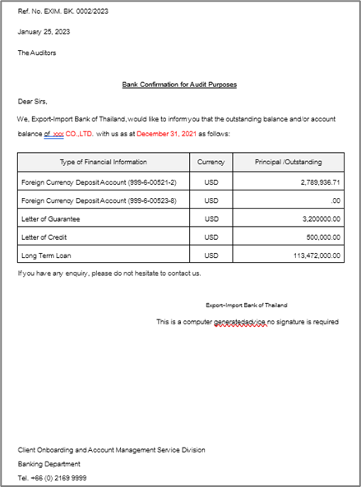

##### Report Data Sheet

The report contains standard text labels + balances from various products / business domains

| Report Field Name/Attributes | Source/Validations |
| --- | --- |
| Customer Name ( English Name) | Customer Name based on:  Account Owner (for Deposits), Borrower (for Lending), Customer or client for other modules’s account or transaction |
| Date Report Generation | As and when report is generated from CBS |
| Type of Financial Information  (Customer product availment from Product Master Account) | Deposit Account records (current, savings, term deposit accounts)  Loan Account records (short term, long term, etc.)  Trade Accounts records (LCs, Guarantees, Bills, etc.)  Core – Rloan  Core Insurance  L/G Claim |
| Foreign Currency Deposit Account | Deposit Account records  Currency  Principal Outstanding  Interest Outstanding |
| Account Number | Account Number to be used as label in Type of Financial Information table |
| Master Account Record based on Domain | Loan  Currency  Principal Outstanding |
|  | Deposit Account  Currency  Principal Outstanding |
|  | AS/400 Trade Finance ( Export, Import , PSF)  Currency  Principal Outstanding |
|  | Trade Instruments (L/G)  Currency  Principal Outstanding |
|  | Core – Rloan  Currency  Principal Outstanding |
|  | Core Insurance  Currency  Principal Outstanding |
|  | L/G Claim  Currency  Principal Outstanding |

#### State Auditor Office Letter – Thai version

##### Report Parameter Criteria

| Report Parameter Field | Source/Validations |
| --- | --- |
| Paper Size | A4 (one page per customer) |
| Search Criteria | All customer records from CBS9 Product Master Account repository (Internal and External account tables) |
| This option will be limited to particular date from last EOD batch process run  Option to specify current, future date or back dated **beyond** last EOM batch process run will be restricted. |
| Generation Frequency | Monthly |

##### Report Layout



Translated:

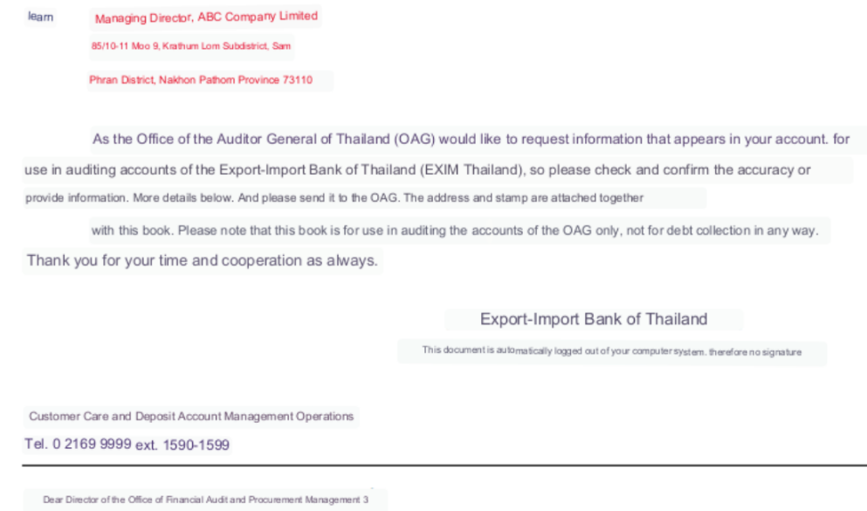

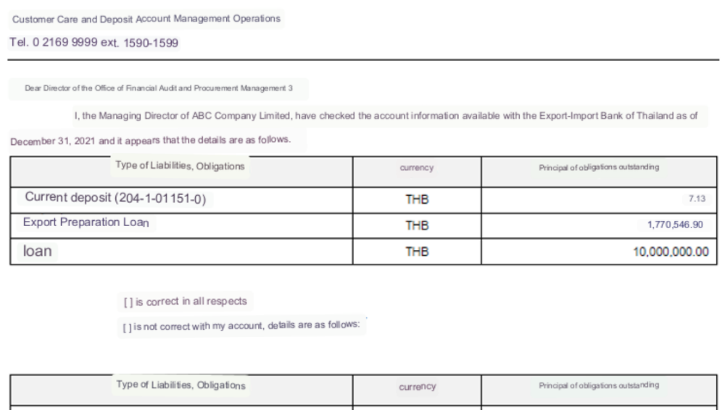

##### Report Data Sheet

The report contains standard text labels + balances from various products / business domains

| Report Field Name/Attributes | Source/Validations |
| --- | --- |
| Current Deposit | Account Number |
| Short Term Loan (Packing Credit : PSF) | Short Term Loan  Principal Outstanding |
| Loan | Long Term Loan  Principal Outstanding |

#### State Auditor Office Letter – English version

##### Report Parameter Criteria

| Report Parameter Field | Source/Validations |
| --- | --- |
| Paper Size | A4 (one page per customer) |
| Search Criteria | All customer records from CBS9 Product Master Account repository (Internal and External account tables) |
| This option will be limited to particular date from last EOD batch process run.  Option to specify current, future date or back dated **beyond** last EOM batch process run will be restricted. |
| Generation Frequency | Monthly |

##### Report Layout

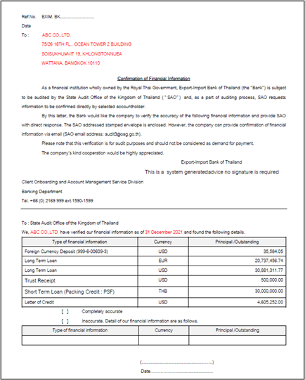

##### Report Data Sheet

The report contains standard text labels + balances from various products / business domains

| Report Field Name/Attributes | Source/Validations |
| --- | --- |
| Customer Name | Customer Name based on:  Account Owner (for Deposits), Borrower (for Lending), Customer or client for other modules’s account or transaction |
| Date Report Generation | As and when report is generated from CBS such as 31 December 2021 |
| Type of Financial Information  (Customer product availment from Product Master Account) | Deposit Account records (current, savings, term deposit accounts)  Loan Account records (short term, long term, etc.)  Trade Accounts records (LCs, Guarantees, Bills, Trust Receipt , Letter of Credit etc.) |
| Foreign Currency Deposit Account | Deposit Account records  Currency  Principal Outstanding |
| Account Number | Account Number to be used as label in Type of Financial Information table |
| Master Account Record based on Domain | Loan  Currency  Principal Outstanding |
|  | Deposit Account  Currency  Principal Outstanding |
|  | AS/400 Trade Finance ( Export, Import , PSF)  Currency  Principal Outstanding |
|  | Trade Instruments (L/G)  Currency  Principal Outstanding |
|  | Core – Rloan  Currency  Principal Outstanding |
|  | Core Insurance  Currency  Principal Outstanding |
|  | L/G Claim  Currency  Principal Outstanding |

#### Outstanding Balance Report

-

##### Report Parameter Criteria

| Report Parameter Field | Source/Validations |
| --- | --- |
| Paper Size | A4 (one page per customer) |
| Search Criteria | All customer records from CBS9 Product Master Account repository (Internal and External account tables) |
| This option will be limited to particular date from last EOD batch process run. Option to specify current, future date or back dated **beyond** last EOD batch process run will be restricted. |
| Generation Frequency | Daily |

##### Report Layout



##### Report Data Sheet

The report contains standard text labels + balances from various products / business domains

| Report Field Name/Attributes | Source/Validations |
| --- | --- |
| Customer Name | Customer Name based on:  Account Owner (for Deposits), Borrower (for Lending), Customer or client for other modules’s account or transaction |
| Date Report Generation | As and when report is generated from CBS such as December 31,2021 ( ณ วันที่ 31 ธันวาคม 2565) |
| Type of Financial Information  (Customer product availment from Product Master Account) | Deposit Account records (current, savings, term deposit accounts)  Loan Account records (short term, long term, etc.)  Trade Accounts records (LCs, Guarantees, Bills, etc.) |
| Foreign Currency Deposit Account | Deposit Account records  Currency  Principal Outstanding |
| Account Number | Account Number to be used as label in Type of Financial Information table |
| Master Account Record based on Domain | Loan  Currency  Principal Outstanding |
|  | Deposit Account  Currency  Principal Outstanding |
|  | AS/400 Trade Finance ( Export, Import , PSF)  Currency  Principal Outstanding |
|  | Trade Instruments (L/G)  Currency  Principal Outstanding |
|  | Core – Rloan  Currency  Principal Outstanding |
|  | Core Insurance  Currency  Principal Outstanding |
|  | L/G Claim  Currency  Principal Outstanding |

#### Loan Details

##### Report Parameter Criteria

| Report Parameter Field | Source/Validations |
| --- | --- |
| Paper Size | A4 (one page per customer) |
| Search Criteria | All customer records from CBS9 Product Master Account repository (Internal and External account tables) |
| This option will be limited to particular date from last EOD batch process run. Option to specify current, future date or back dated **beyond** last EOM batch process run will be restricted. |
| Generation Frequency | Monthly |

##### Report Layout

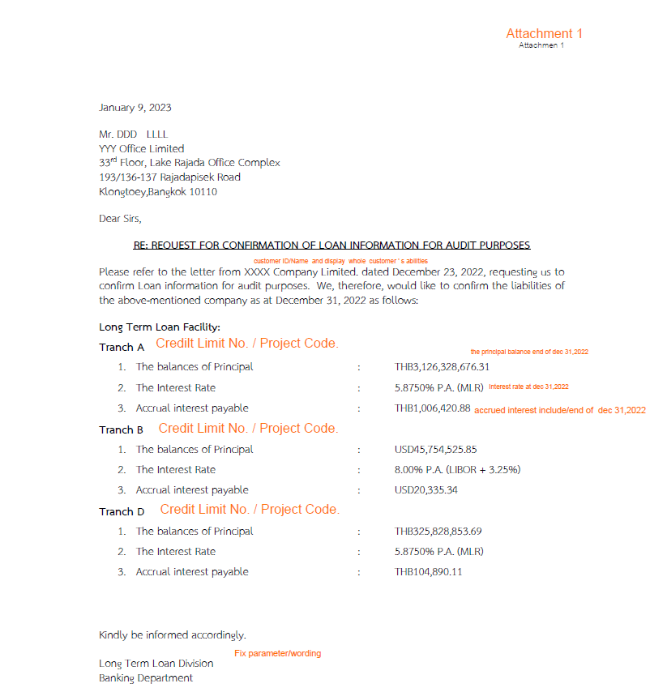

##### Report Data Sheet

The report contains standard text labels + balances from various products / business domains

| Report Field Name/Attributes | Source/Validations |
| --- | --- |
| Customer Name | Customer Name based on:  Account Owner (for Deposits), Borrower (for Lending), Customer or client for other modules’s account or transaction |
| Date Report Generation | As and when report is generated from CBS such as December 31,2022 |
| Tranch A / Credit Limit No./Project Code. | Loan Account records  Currency  Principal Outstanding  Interest Rate p.a.  Interest Payable |
| Tranch B / Credit Limit No./Project Code. | Loan Account records  Currency  Principal Outstanding  Interest Rate p.a.  Interest Payable |
| Tranch D / Credit Limit No./Project Code. | Loan Account records  Currency  Principal Outstanding  Interest Rate p.a.  Interest Payable |

### Additional Impacts

#### System Interface requirement /Integration

* Interface with AS/400 for Trade Finance transactions outstanding balance, for further details please refer to ISD-15 AS/400
* Interface with Core- RLoan for Restructuring Loan transactions outstanding balance, for further details please refer to ISD-16 Core RLoan
* Interface with Core- Insurance for all relevant contingent/liabilities under export insurance , for further details please refer to ISD-17 Core-INS

#### Migration

Based on agreed cut-off date, balances (previous End of year) balances will be migrated. Further details based will be covered in Migration Stragegy Document.

#### Fit/Gap Analysis Report

